Estimation and Planning

*Team CAtS (Yihong Zou, Huairui Qi, Siqi Lu, Yun-Hsuan Chang)*

**Work Breakdown structure** **2**

**Milestones** **2**

**Milestone Dependencies** **3**

**Milestone-WBS Mapping** **4**

**Milestone Adjustment** **5**

**Strategy of Tracking** **6**

# Work Breakdown structure

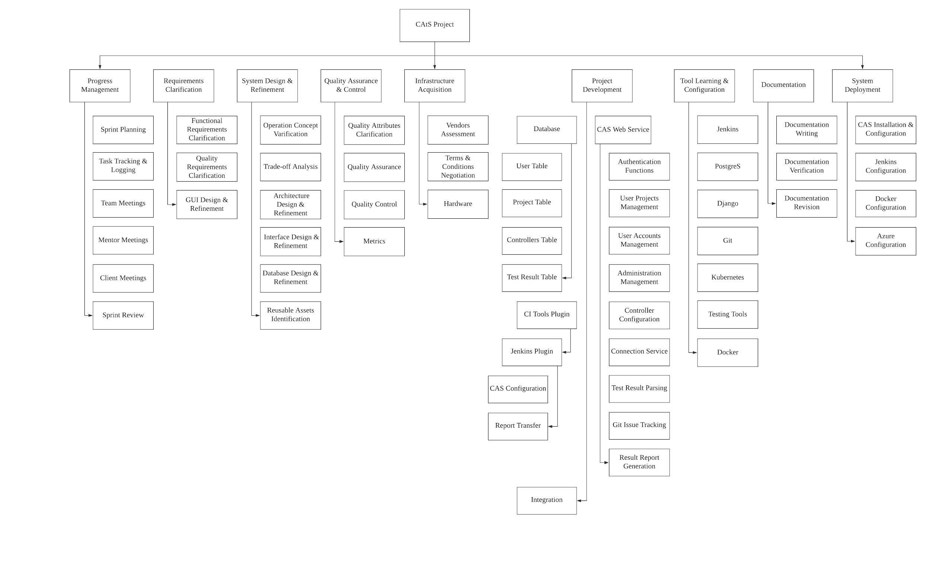

Figure 1. Work Breakdown Structure

# Milestones

|  |  |  |  |  |
| --- | --- | --- | --- | --- |
| **Milestone ID** | **Date** | **Milestone Description** | **Team** | **Client** |
| 1 | May. 22 | Fix existing CATS system | x |  |
| 2 | May. 24 | Implement new features | x |  |
| 3 | May. 26 | System Testing 1 | x |  |
| 4 | May. 27 | Client Verification 1 |  | x |
| 5 | Jun. 27 | Fully implement required features | x |  |
| 6 | Jul. 4 | System Testing 2 | x | x |
| 7 | Jul. 11 | Clients Verification 2 |  | x |
| 8 | Jul. 25 | Deploy the CATS system on Azure | x |  |
| 9 | Jul. 30 | Deployment Testing | x | x |
| 10 | Aug. 1 | Clients Verification 3 |  | x |
| 11 | Aug. 3 | Documentation | x |  |
| 12 | Aug. 4 | Summer EOSP | x |  |

Table 1. Discarded Milestones

# Milestone Dependencies

Milestone on the left depends on the milestone on the top.

|  |  |  |  |  |  |  |  |  |  |  |  |  |
| --- | --- | --- | --- | --- | --- | --- | --- | --- | --- | --- | --- | --- |
| Seq | 1 | 2 | 3 | 4 | 5 | 6 | 7 | 8 | 9 | 10 | 11 | 12 |
| 1 | 1 |  |  |  |  |  |  |  |  |  |  |  |
| 2 |  | 2 |  |  |  |  |  |  |  |  |  |  |
| 3 | x | x | 3 |  |  |  |  |  |  |  |  |  |
| 4 |  |  | x | 4 |  |  |  |  |  |  |  |  |
| 5 |  |  |  |  | 5 |  |  |  |  |  |  |  |
| 6 |  |  |  |  | x | 6 |  |  |  |  |  |  |
| 7 |  |  |  |  |  | x | 7 |  |  |  |  |  |
| 8 |  |  |  | x |  |  | x | 8 |  |  |  |  |
| 9 |  |  |  |  |  |  |  | x | 9 |  |  |  |
| 10 |  |  |  |  |  |  |  |  | x | 10 |  |  |
| 11 |  |  |  |  |  |  |  |  | x |  | 11 |  |
| 12 |  |  |  |  |  |  |  |  |  |  | x | 12 |

Table 2. Milestone Dependencies

# Milestone-WBS Mapping

|  |  |  |  |  |  |  |  |  |  |  |  |  |  |
| --- | --- | --- | --- | --- | --- | --- | --- | --- | --- | --- | --- | --- | --- |
| WBS/Milestones | 1 | 2 | 3 | 4 | 5 | 6 | 7 | 8 | 9 | 10 | 11 | 12 | Total Hours |
| Progress Management | 4 | 6 | 4 | 2 | 8 | 4 | 4 | 2 | 2 | 2 | 2 |  | 40 |
| Requirements Clarification | 2 | 1 | 1 | 2 | 12 | 2 |  |  |  |  |  |  | 20 |
| System Design & Refine | 2 | 10 | 4 |  | 18 |  |  |  |  |  |  |  | 34 |
| Quality Attributes |  |  |  |  | 10 | 10 |  |  |  |  |  |  | 20 |
| Quality Control |  |  | 10 | 4 | 8 | 40 |  |  |  |  |  |  | 62 |
| Infrastructure Acquisition |  |  |  |  |  |  |  |  |  |  |  |  | 0 |
| Authentication Functions |  |  |  |  | 8 |  |  |  |  |  |  |  | 8 |
| User Account Mngt |  | 20 |  |  | 6 |  |  |  |  |  |  |  | 26 |
| User Projects Mngt |  | 15 |  |  | 10 |  |  |  |  |  |  |  | 25 |
| Admin Management |  |  |  |  | 20 |  |  |  |  |  |  |  | 20 |
| Controllers Configuration |  |  |  |  | 10 |  |  |  |  |  |  |  | 10 |
| Connection Service |  |  |  |  | 10 |  |  |  |  |  |  |  | 10 |
| Test Results Parsing |  |  | 14 |  | 20 |  |  |  |  |  |  |  | 34 |
| Git Issue Tracking |  |  |  |  | 20 |  |  |  |  |  |  |  | 20 |
| Test Report Generation |  |  |  |  | 16 |  |  |  |  |  |  |  | 16 |
| Functional Integration |  |  |  |  | 6 | 30 |  | 10 | 10 |  |  |  | 56 |
| Database Management |  | 8 |  |  | 20 |  |  |  |  |  |  |  | 28 |
| Tools Learning | 9 | 6 |  |  | 12 |  |  | 20 |  |  |  |  | 47 |
| CAS Installation |  | 12 |  |  | 20 |  |  | 5 |  |  |  |  | 37 |
| Jenkins Configuration |  | 17 | 8 |  | 40 |  |  | 5 |  |  |  |  | 70 |
| Docker Configuration |  |  | 4 |  |  |  |  | 20 |  |  |  |  | 24 |
| Azure Configuration |  |  |  |  |  |  |  | 40 | 40 |  |  |  | 80 |
| Plugin Configuration |  |  | 12 |  | 30 |  |  | 5 |  |  |  |  | 47 |
| Documentation |  |  |  |  |  |  |  | 12 | 20 |  | 80 |  | 112 |
| Total Hours | 17 | 95 | 57 | 8 | 304 | 86 | 4 | 119 | 72 | 2 | 82 | 0 | 846 |

Table 3. Milestone-WBS Mapping

# Milestone Adjustment

After each sprint, we review the task board and opening issues to determine whether to adjust our milestone deadline as the foreseen date.

|  |  |  |  |
| --- | --- | --- | --- |
| **Milestone Description** | **Planned Date** | **Foreseen Date** | **Actual Date** |
| Fix existing CATS system | May. 22 | May. 22 | May. 20 |
| Client Verification 1 | May. 27 | Jun. 1 | Jun. 1 |
| Clients Verification 2 | Jul. 11 | Jul. 13 | Jul. 13 |
| Deploy the CATS system on Azure | Jul. 25 | Jul. 25 | Jul.19 |
| Deployment Testing | Jul. 30 | Jul. 25 | Jul.22 |
| Clients Verification 3 | Aug. 1 | Jul.23 | Jul.23 |
| Documentation | Aug. 3 | Aug. 3 | Jul. 31 |

Table 4. Milestone Adjustment

# Strategy of Tracking

* We tracked every task on Github to record the time to work on each part of the project in the Milestone-WBS mapping.
* Everyone is supposed to record the tasks they do.
* Accumulated completed story points were calculated every day.

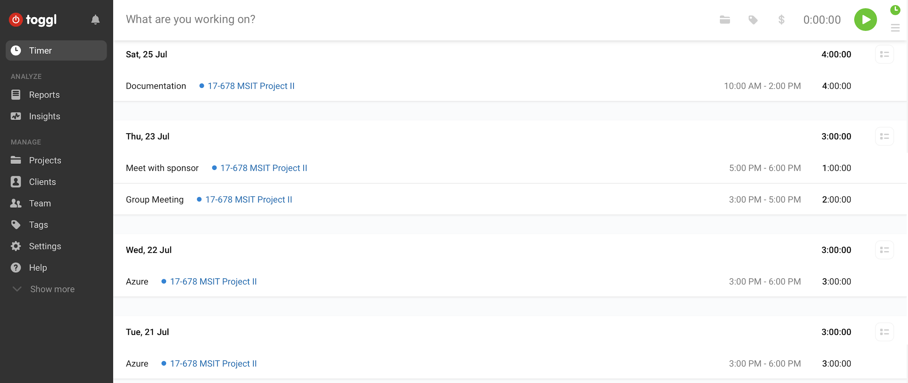

Figure 2. Time logging

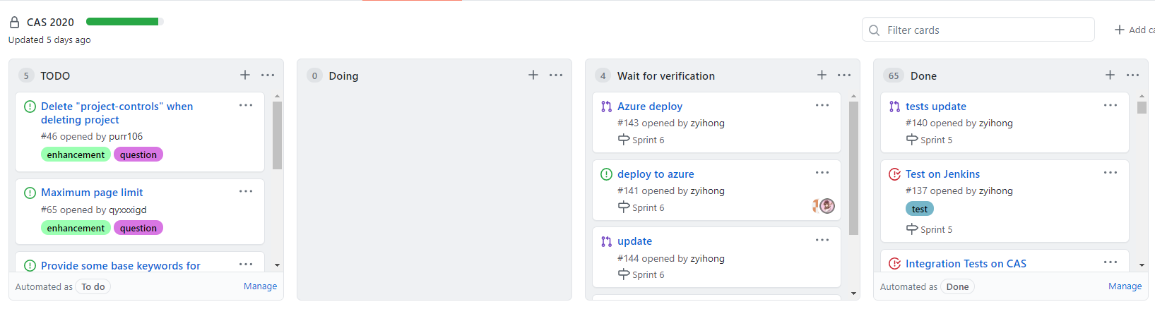

Figure 3. Task board

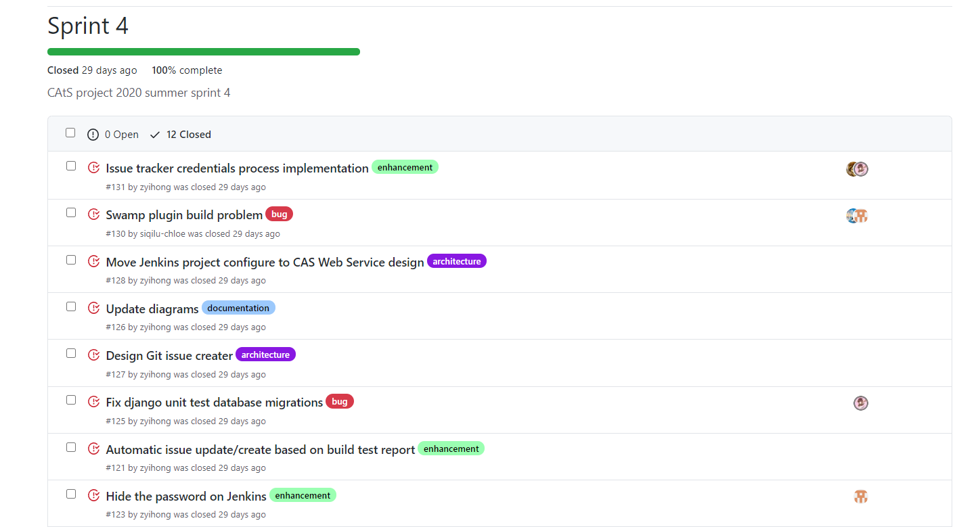

Figure 4. Backlog